**Azure SQL DB features and practices for - ICS**

1. **Advanced Data Security for Azure SQL**
2. Advanced data security is a unified package for advanced SQL security capabilities. It includes functionality for discovering and classifying sensitive data, surfacing and mitigating potential database vulnerabilities, and detecting anomalous activities that could indicate a threat to your database.
3. Data discovery & classification: for discovering, classifying, labeling & protecting the sensitive data
4. Vulnerability assessment discover, track, and help you remediate potential database vulnerabilities
5. Advanced Threat Protection: detects anomalous activities indicating unusual and potentially harmful attempts to access or exploit your database

Note: Advanced Data Security for all databases on the server, at the cost of 15 USD/server/month.

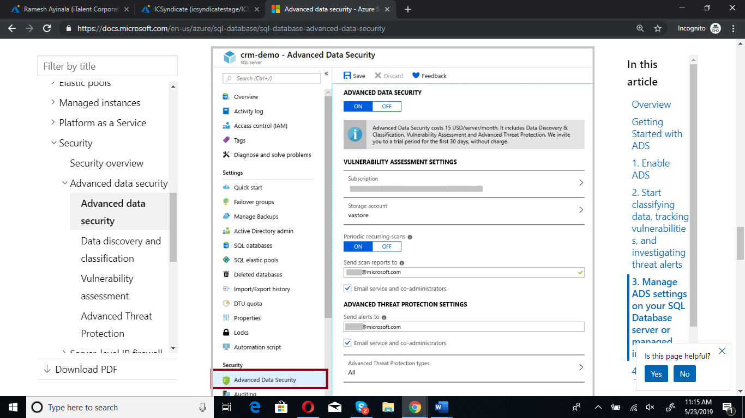

1. **SQL database auditing**
2. Auditing for Azure SQL Database tracks database events and writes them to an audit log in Azure storage account, OMS workspace or Event Hubs.
3. Retain an audit trail of selected events.
4. Report on database activity.
5. Analyze reports.
6. server-level and database-level auditing policy.

Note: Cost is $2.30 per GB , and first 5 GB per customer per month is Free.

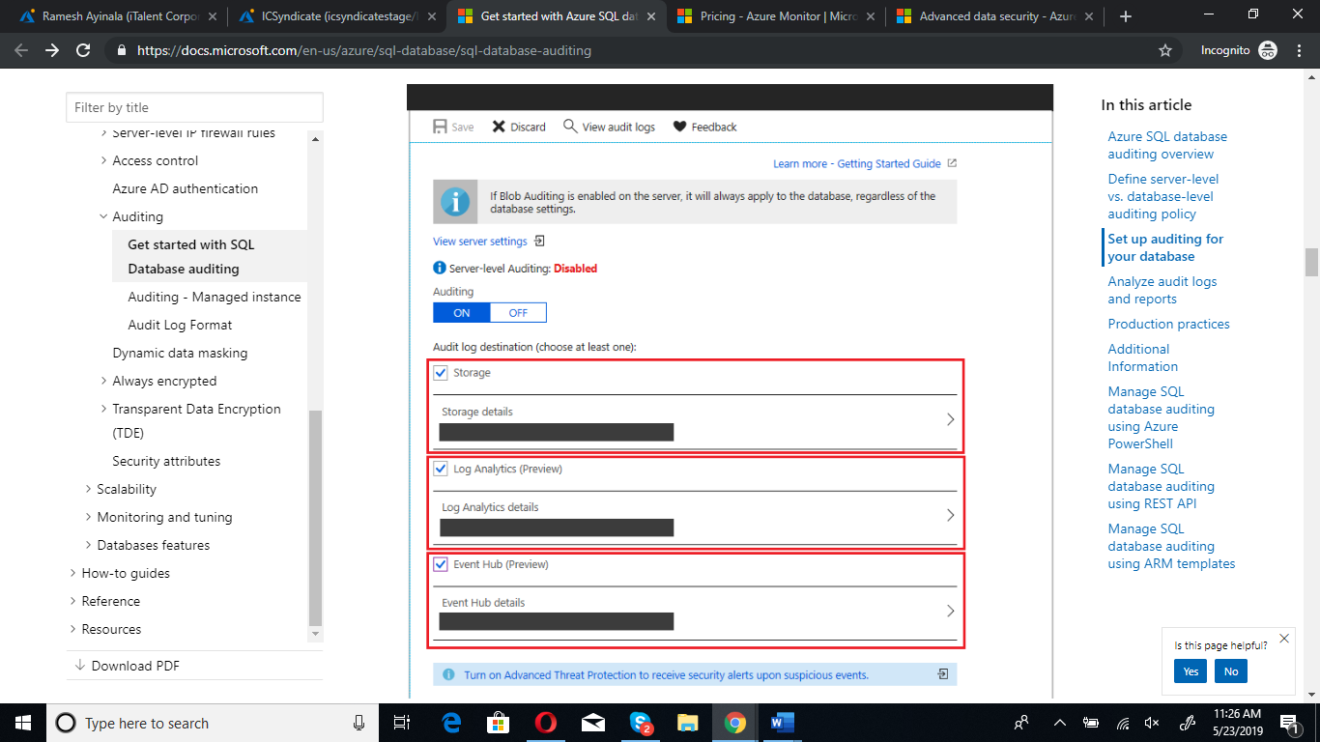

1. **Transparent data encryption**
2. Encrypts your databases, backups, and logs at rest without any changes to the application.

It is on By Default.

1. **Geo-replication**

Active geo-replication is designed as a business continuity solution that allows the application to perform quick disaster recovery of individual databases in case of a regional disaster or large scale outage.

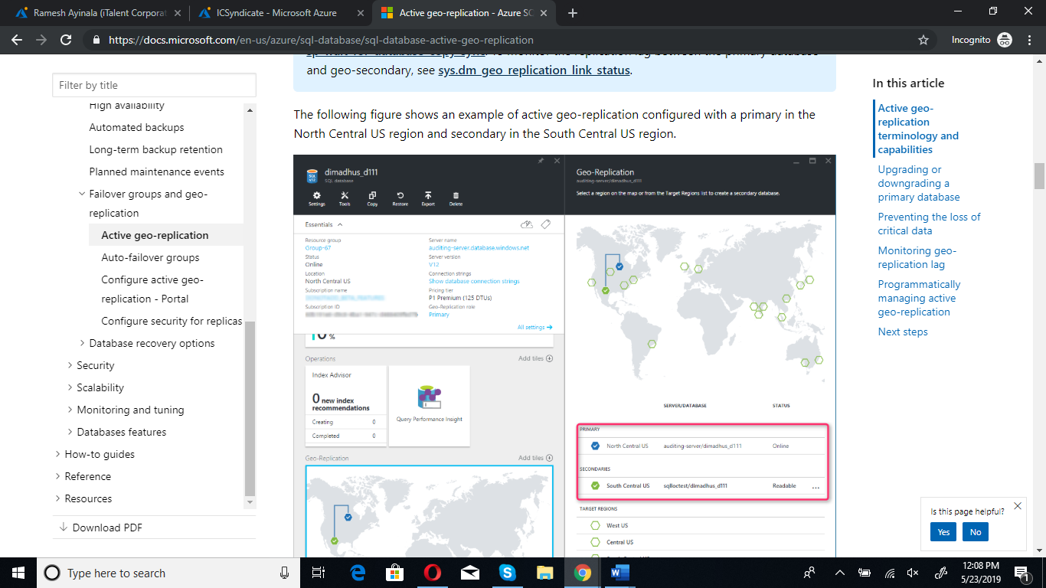

1. **Backup and Restore:**

With the release of the Basic, Standard, and Premium Azure SQL Database service tiers, Azure provide built-in backup and restore capabilities. (We opt for Standard tier).

Basic, standard, and premium databases are backed up automatically in Azure SQL Database. These backups are retained for max 35 days. With these backups Azure SQL Database supports two restore capabilities.

Point in Time Restore: allows a database to be restored to any point in time, up to the millisecond, within a database’s retention period.

Geo-Restore: utilizes a database’s latest geo-redundant backup to recover a database. This means a database can be recovered in the event of a regional outage with the 1 hour old geo-redundant backup.

Alerts:

We can set Metric alerts on

CPU Percentage -> Is greater than X% -> Over Y min -> email to ---

DTU Percentage -> Is greater than X% -> over Y min ->email to ---

Data Space Used -> Is grater than X bites -> over Y min ->email to ---

Failed Connections -> Is grate than X -> over X min -> email to ---

DTU used -> Is grater than X -> over X min -> email to ---

Please check this and share your ideas.